Position: | Manager - Infrastructure
Division: | Infrastructure
Department: | Operations
Reporting to | Division Manager - Infrastructure
Direct Reports | Infrastructure Coordinator/s  Infrastructure Assistant
Employment Type | Full Time / Permanent

Key Relationships | Internal  - Division Manager – Infrastructure  - General Manager Operations  - CEO  - Division Manager – Risk and Operations  - Risk and Safety Manager  - General Manager – Business Services and Manager – Finance  - Sales, Commercial and Marketing Departments  - Partnerships Team  - Operations Department  - IT team  - Finance team  - Legal, Strategy and Contracts Department  - Motorsport, Entertainment and Industry Department  - Key direct reports  - All staff  - Other internal stakeholders as relevant and appropriate  External  - Linfox  - Phillip Island Operations (PIO)  - APP Corporation (F1 Engineering Project Manager)  - Parks Victoria, Park tenants and local community  - Contractors and Suppliers  - Utilities service providers  - Corporate clients and sponsors (as required)  - Formula One Management, Dorna, FIM, FIA, Motorsport Australia, Motorcycling Australia  - Local Government (CoPP and BCSC)  - Worksafe, Energy Safe Victoria, Victorian Building Authority and other regulatory authorities.  - Key suppliers and commercial partners  - Other stakeholders as relevant and appropriate

Values | Knowledge of and consistent demonstration of the Corporation’s IIQCAT values: Integrity, Innovation, Quality, Customer, Accountability, Teamwork.  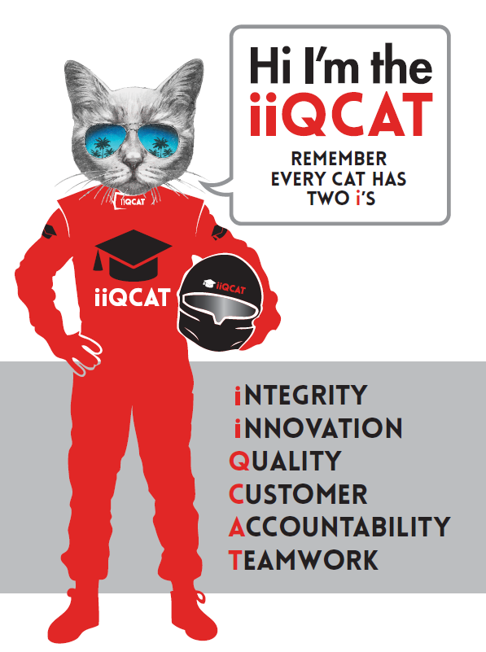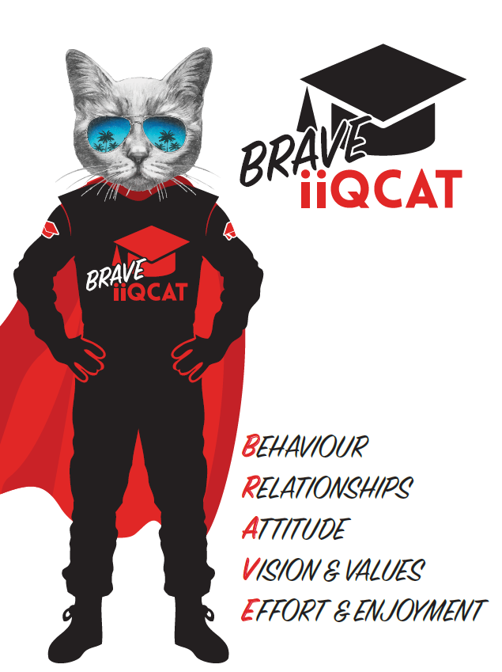
Corporation Objectives | To promote Melbourne and Victoria via the staging of two international sporting events - the Formula 1 Australian Grand Prix at Albert Park and the Australian MotoGP at Phillip Island.
Governed by | The Corporation is governed by the Australian Grands Prix Act 1994 (Vic).
Standards of behaviour | The Code of Conduct for Victorian Public-Sector Employees governs the behaviour of all Corporation employees.
Human Rights | The Charter of Human Rights and Responsibilities Act 2006 is a Victorian law that sets out the basic rights, freedoms and responsibilities of all people in Victoria. The Charter requires the Corporation to act compatibly with human rights, and to consider human rights when developing policies, making laws, delivering services and making decisions.

Role Objectives | This role is responsible for the successful, delivery and operation of Infrastructure services for both the Formula 1 Australian Grand Prix and the Australian Motorcycle Grand Prix.  The Manager – Infrastructure will primarily hold the responsibility for the project management delivery of Infrastructure services for the Australian Motorcycle Grand Prix. The key functions and deliverables of the role inlcude:  - Project management and planning.  - Event facility overlay planning and design (Circuit Planning and Facility Planning)  - All track related infrastructure and motorsport facilities required for motor racing activities.  - All event facilities and infrastructure services for the staging of the event activities.  - Detailed financial control and reporting.  - Construction and contractor management.  - Site, safety and compliance management.  - Construction works scheduling and programme management.  - Close management of stakeholder relationships for the successful delivery of the above.  - Coordination of AGPC assets from the storage yard to site.  - Team management, leadership and support to the team.  - Build and maintain a powerful organisational culture.  - In consultation with key stakeholders, planning for ongoing improvement projects for the track and circuit as required.  - Achieving track certification through the effective management of track homologation requirements.
Core Responsibilities | General  Responsible for:  - Providing oversight, leadership and support to the infrastructure team.  - Acting as AGPC’s representative for the implementation of all infrastructure works necessary for the staging of the MotoGP event.  - Implementation of infrastructure works and activities in accordance with project schedules, plans and AGPC’s Timeline Manager.  - Contribution to and implementation of works in accordance with AGPC Risk Management framework including adherence to health and safety systems and policies.  - Delivery of the infrastructure works in accordance with AGPC policies and procedures.  - Delivery of the infrastructure works in accordance with the AGP Act and all applicable licences and contracts.  Project and Construction Management  Responsible for:  - Project management of the Australian Motorcycle Grand Prix infrastructure works, including but not limited to:  - Procurement and contract Administration.  - Scheduling and programme management.  - Site management and construction management.  - Management of all relevant compliance requirements, licenses, and contractual deliverables relating to the infrastructure project.  - Contractor and third-party management and supervision.  - Delivery of all aspects of the event build including circuit planning and venue design, temporary facility overlay and corporate facilities.  In relation to the Formula 1 event, the Manager – Infrastructure will play a key leadership role through supporting the project management deliverables of the AGPC Infrastructure team, including but not limited to:  - Support with the management and supervision of the F1 Engineering Project Manager (APP Corporation).  - Implementation of the Engineering Project Management Services Contract for the Formula 1 Grand Prix.  - Oversight of third-party compliance processes for AGPC appointed contractors.  - Stakeholder liaison, consultation and communication.  Facilities and Infrastructure  Responsible for:  - Event Facility overlay planning.  - Delivery of Track Infrastructure and Motorsport Facilities in accordance with FIA and FIM guidelines, Formula 1, Formula 1 Team’s, Motorsport Australia, Motorcycling Australia, Dorna and IRTA.  - Event Facilities comprising of:  - Delivery of Corporate, grandstand, general admission and sponsor facilities to the required standards in support of commercial activities of the business; and  - Delivery of catering, merchandise and other concessionaire facilities for the provision of those services for the event and the view to maximise yield from those facilities  - Delivery of all other facilities required for the safe and efficient staging of all other aspects of the event delivering on the needs of customers / stakeholders to an exceptional standard.  - Event and sponsor signage overlay requirements.  Financial Control and Reporting  Responsible for:  - Annual preparation of the recurrent and capital budgets for the Australian Motorcycle Grand Prix.  - Delivery of all infrastructure for the Australian Motorcycle Grand Prix in accordance with approved budgets.  - Implementation of cost control and savings initiatives.  - Accurate and regular update of budget and cost control documents and reporting of forecast final costs against the approved budgets.  - Preparation of in cost analysis of Infrastructure options and solutions.  Stakeholder Relationship Management  Responsible for:  - Establishing a good relationship with the Linfox Group as the landlords for Phillip Island circuit.  - Management of key external relationships to ensure the effective and efficient delivery and operation of Grand Prix infrastructure and minimise the negative impacts of the Grand Prix infrastructure project on external stakeholders.  Safety and Compliance  Responsible for:  - Review and implementation of the infrastructure health and safety management plan for the Australian Motorcycle Grand Prix.  - Ensuring adequate arrangements for the safe delivery of the infrastructure build, delivery and dismantle.  - Site management of the venue and ensuring adherence to all site safety requirements by AGPC personnel and third parties on site.  - Cooperating with external stakeholders to address any safety or compliance related matters.  - So far as is reasonably practicable, provide and maintain an environment which is safe and free from harm.  Asset Maintenance and Capital Works Management  Responsible for:  - Coordination and oversight of the capital works plan for the Australian Motorcycle Grand Prix.  - Coordination and oversight of the homologation requirements for the Australian Motorcycle Grand Prix.  - Management of assets in accordance with AGPC’s asset management plan.  Leadership  Responsible for:  - Provide support, advice and leadership to members of the infrastructure team (especially direct reports), to drive a strong culture, motivation, performance and achievement of outcomes.  - Lead by example and in alignment with AGPC values to ensure a cohesive, constructive and trust driven team culture.  - Ensure appropriate development, succession, performance review and monitoring procedures/strategies are in place/maintained for team members.  At the reasonable request of your Division Manager, General Manager and/or the Chief Executive Officer, role responsibilities may be altered at any time. Such changes will be aligned to the Corporation’s strategic objectives, workforce planning and the structural alignment of the Corporation.  Governance  Adhere to Corporation policies, procedures, and directives regarding standards of workplace behaviour in completing job duties and assignments.  Conducting every aspect of work in a trustworthy, reliable and transparent manner, and maintaining the highest ethical standards.  Customer Service  Putting internal and external customers first, building strong relationships and ensuring that the approach is responsive to the needs of the internal/external customer.  Encouraging openness and trust by sharing information widely, listening, welcoming constructive challenge and encouraging free dialogue.  Continuous Improvement  Taking initiative to improve operations/services/products and systems so that they are consistent with the Corporation’s strategic direction and values; incorporating innovation and experimentation into daily work.  Health and Safety  To assist the Corporation in meeting its health and safety obligations you will be required to:  - Actively participate in the reporting of hazards, incidents and near misses.  - Take corrective action to address or mitigate any risks or hazardous situations throughout the course of your work.  - Take reasonable care for your own health and safety, and for the health and safety of others.  - Adhere to the Corporation’s various policies, procedures, work practices and standard operating procedures.  - Perform your role in accordance with any specific responsibilities as outlined in the Corporation’s safety management system.  To enable the Corporation to meet its obligations for providing a healthy and safe working environment for you, you must inform your manager of any issues which may impact your ability to safely perform your role.  Environmental Sustainability  Cooperate with the Corporation regarding caring for the environment, by acting in a sustainable way and minimising environmental impact by adhering to the Corporation’s policies, procedures and work practices.

Person Specification

Qualifications and Experience | Tertiary qualification in project management or other discipline that developed the same attributes.  Minimum 5 years’ experience in major event infrastructure construction or project management of other complex and dynamic projects or operations.  Demonstrated commercial experience and acumen.

Relevant Traits and Characteristics | Customer Service:  - Demonstrated achievement in and enthusiasm for the provision of quality customer service  - Immediately respond to customers’ needs or concerns to ensure the quality of service meets agreed standards  Teamwork, Adaptability and Resilience:  - Demonstrated commitment to teamwork and the maintenance of a supportive work environment  - Ability to work effectively as part of a team in a fast-changing environment  - Keeping calm by demonstrating a capacity to positively deal with unanticipated problems and changing circumstances  Interpersonal, Verbal and Written Communication:  - Well-developed written communication ability  - Strong interpersonal and communication skills  - An ability to liaise, negotiate and constructively provide and accept feedback from staff at all levels  Organisation and Planning:  - Organisational and planning skills in managing a personal workload in a busy environment with conflicting demands  - Ability to meet deadlines  Technology:  - Experience in the use of Microsoft desktop products such as Word, Excel, Outlook and PowerPoint  - Experience in information management systems, including internet and on-line environments  - Experience in the use of AutoCAD and MS Project is desirable  Continuous Learning and Professional Development  - Demonstrated commitment to continual professional and personal development

